PRACTICAL 1 :
IP SLA Tracking & Path Control

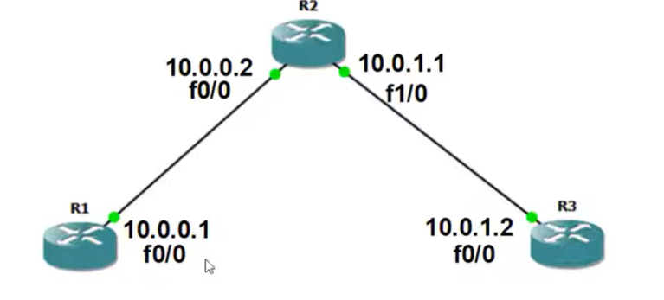

Select slot : Slot 0 :- C7200-IO-FE
Slot 1 :- PA-FE-TX
Configuration of R1:-
R1 # config t
R1 (config) #interface fastethernet0/0
R1 (config-if) # ip address 10.0.0.1 255.255.255.0
R1 (config-if) # no shutdown
R1 (config-if) # exit
R1 (config) # router rip
R1 (config-router) # version 2
R1 (config-router) # network 10.0.0.0
R1 (config-router) # exit
R1 (config) # ip sla 1
R1 (config-ip-sla) # time
R1 (config-ip-sla) # icmp-echo 10.0.1.2
R1(config-ip-sla-echo) # timeout 1000
R1 (config-ip-sla-echo) # frequency 3
R1 (config-ip-sla-echo) # exit
R1 (config) # ip sla schedule 1 life forever start-time now
R1 (config) # track 1 rtr 1 reachability
R1 (config-track) # exit
R1 (config) # ip route 0.0.0.0 0.0.0.0 10.0.0.2 track 1
R1 (config) # ip route 0.0.0.0 0.0.0.0 10.0.0.1.2 10
R1(config) # exit

R2
Configuration of R2:-
R2 # config t
R2 (config) #interface fastethernet0/0
R2 (config-if) # ip address 10.0.0.2 255.255.255.0
R2 (config-if) # no shutdown
R2 (config-if) # exit
R2 (config) #interface fastethernet1/0
R2 (config-if) # ip address 10.0.1.1 255.255.255.0
R2 (config-if) # no shutdown
R2 (config-if) # exit
R2 (config) # router rip
R2 (config-router) # version 2
R2 (config-router) # network 10.0.0.0
R2 (config-router) # network 10.0.1.0
R2 (config-router) # exit

R3
R3 # config t
R3 (config) #interface fastethernet0/0
R3 (config-if) # ip address 10.0.1.2 255.255.255.0
R3 (config-if) # no shutdown
R3 (config-if) # exit
R3 (config) # router rip
R3 (config-router) # version 2
R3 (config-router) # network 10.0.0.0
R3 (config-router) # exit

R1
To See Output
R1 # show ip route
R1 # show track
R1 # show ip sla statistics
R1 # ping 10.0.0.2

